Assignment 1.1 Installing and experimenting with the development tools

Monday, August 19, 2024

1:24 PM

Screenshot of Draw.io

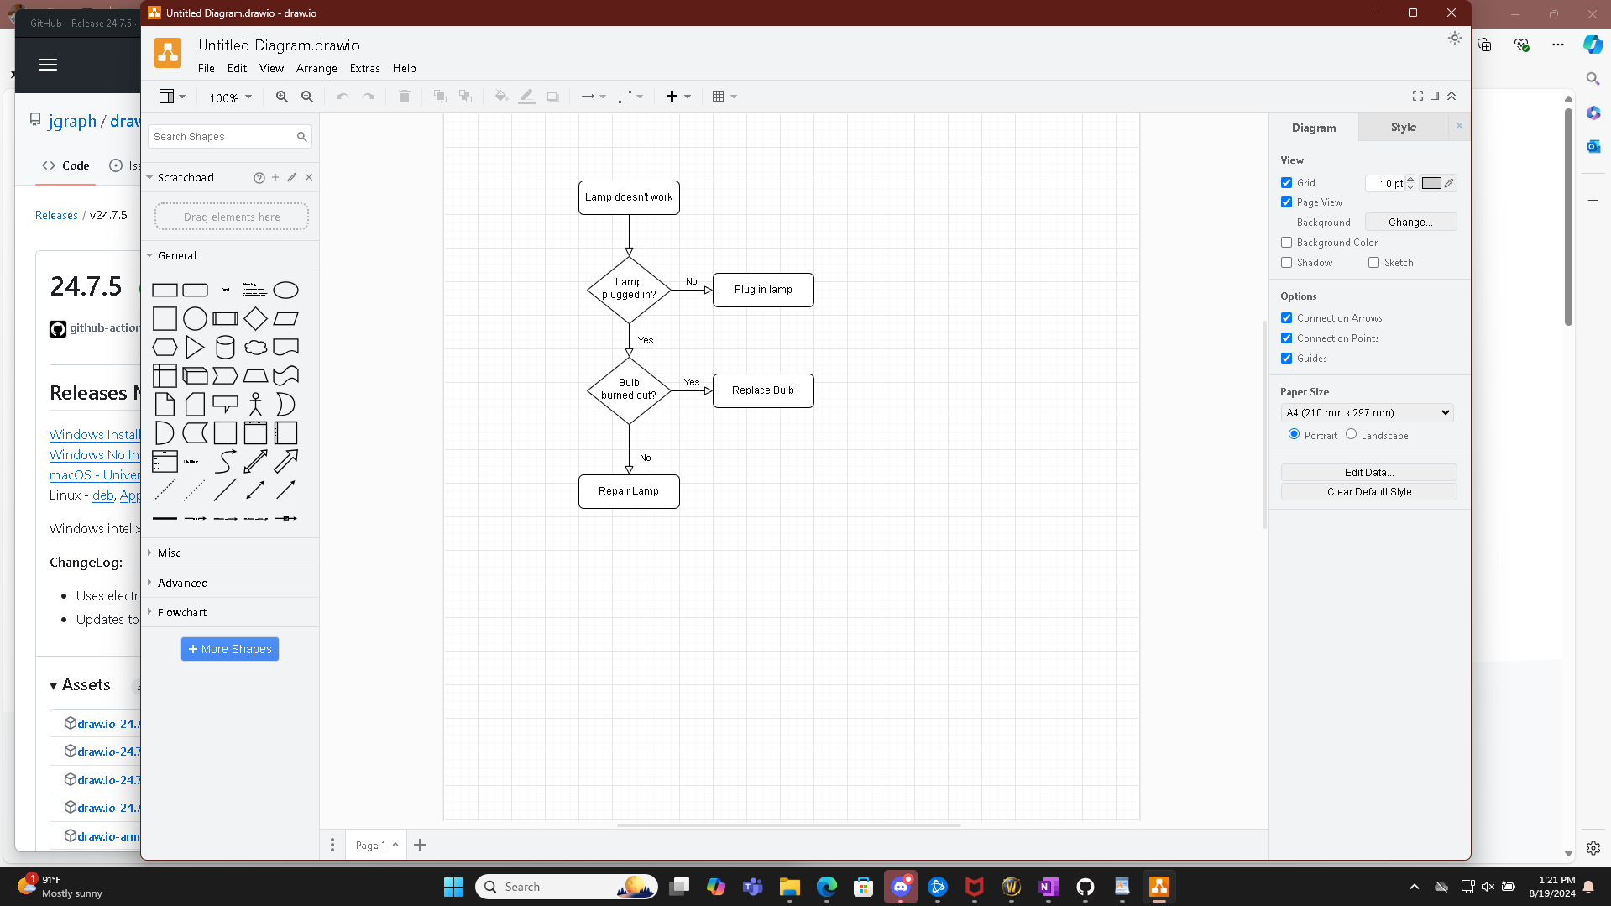

Screenshot of Python IDLE

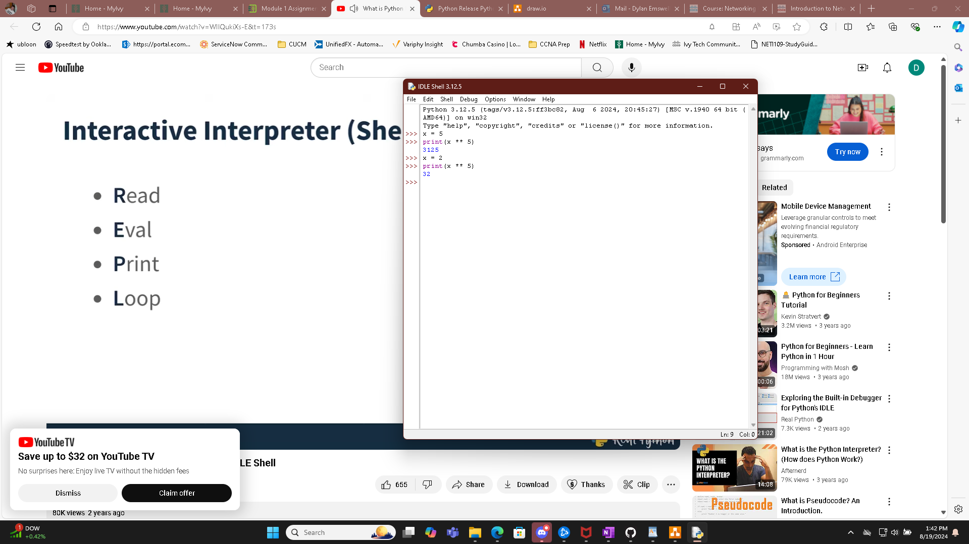

Screenshot of Github installed and signed in.

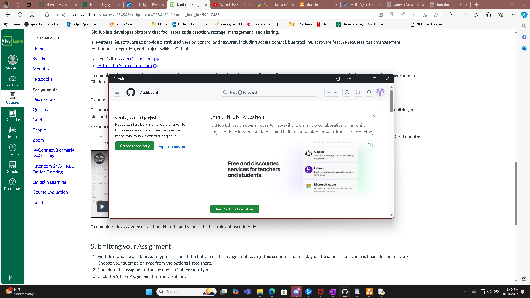

The 5 rules of pseudocode

* Capitalize Keywords (IF,ELESE,WHILE, and FOR)
* One Statement per line
* Indentation (show hierarchy and structure of code)
* End Keywords (ENDIF, ENDWHILE)
* Language Independence ( Focus on logic not a type of programming.)